**RESUME**

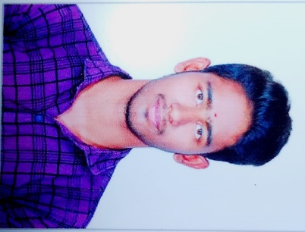 Name: S.K.Kesavan

Rollno:1902025

Degree:B.Tech Information Technology

Email: [surya938586@gmail.com](mailto:surya938586@gmail.com)

Phone no:6380986529

_____________________________________________________________________________________

**Career objectives**

* Looking for opportunities to incorporate my skills and training to help the company grow. I am looking forward to roles that will help me realise my potential by exploring the various aspects of this field.

**Technical skills**

* Programmming language **:** basics in C,python, Php .
* Web development **:** Basics in HTML
* Certificate for Inplant Training (Bootstrap,Mysql)

**Curricular Activities**

* Participated in 3D photoshop animation

**Hobbies**

* Listening Music

* Playing cricket

**Education**:

|  |  |  |  |  |
| --- | --- | --- | --- | --- |
| Qualification | Institution/School | University/Board | Year of passing | Percentage/CGPA |
| B.Tech(IT) | K.L.N College of Information Technology | Anna University | 2023 | 7.68 |
| HSE | P.N.U.A.P.T Dorairaj Hr.sec school | State Board | 2019 | 44 |
| SSLC | P.N.U.A.P.T Dorairaj Hr.sec school | State Board | 2017 | 67.4 |

**Personal details**

Name : S.K.Kesavan

Date of Birth : 18-05-2002

Gender : Male

Nationality : Indian

Languages Known : English,Tamil.

Address : 17/1 O.V.R Compound New Mahalipatti Road Near Railway Gate,Madurai-625001.

**Declaration**

I hereby declare that the information provided is true to the best of my knowledgeand belief